Domain-Driven Design (DDD)
# Source: AI Source: Provided by: [Data Path: Persons Table -> ID Column: 1, Name_En Column: Motasem Essam] -> From: [ChatGPT] on [1/23/2026]
Domain-Driven Design (DDD) is an architectural approach that focuses on modeling software based on the real business domain.
Instead of starting from technical concerns, DDD starts from understanding the business problem deeply.
👉 Build software that reflects real-world business concepts and rules

🔑 Key Idea
# Source: AI Source: Provided by: [Data Path: Persons Table -> ID Column: 1, Name_En Column: Motasem Essam] -> From: [ChatGPT] on [1/23/2026]
Code should look like the business language, not technical jargon.

🧱 Core Concepts of DDD

1️⃣ Domain
# Source: AI Source: Provided by: [Data Path: Persons Table -> ID Column: 1, Name_En Column: Motasem Essam] -> From: [ChatGPT] on [1/23/2026]
- The problem space (e.g., banking, e-commerce, healthcare)

2️⃣ Entity
# Source: AI Source: Provided by: [Data Path: Persons Table -> ID Column: 1, Name_En Column: Motasem Essam] -> From: [ChatGPT] on [1/23/2026]
- Object with identity (e.g., User, Order)
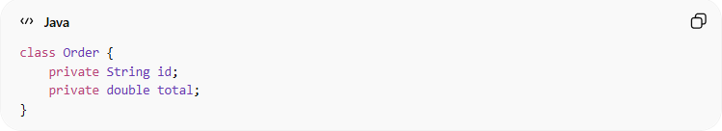
class Order {
private String id;
private double total;
}

3️⃣ Value Object
# Source: AI Source: Provided by: [Data Path: Persons Table -> ID Column: 1, Name_En Column: Motasem Essam] -> From: [ChatGPT] on [1/23/2026]
- Object without identity, defined by value only
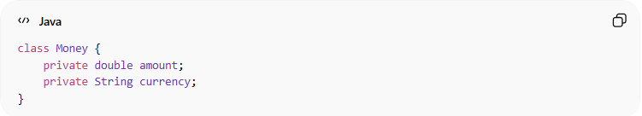
class Money {
private double amount;
private String currency;
}

4️⃣ Aggregate
# Source: AI Source: Provided by: [Data Path: Persons Table -> ID Column: 1, Name_En Column: Motasem Essam] -> From: [ChatGPT] on [1/23/2026]
- A group of related objects treated as one unit
- Has a root (Aggregate Root)
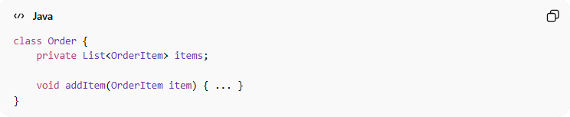
class Order {
private List<OrderItem> items;

void addItem(OrderItem item) { ... }
}

5️⃣ Repository
# Source: AI Source: Provided by: [Data Path: Persons Table -> ID Column: 1, Name_En Column: Motasem Essam] -> From: [ChatGPT] on [1/23/2026]
- Handles data access for aggregates
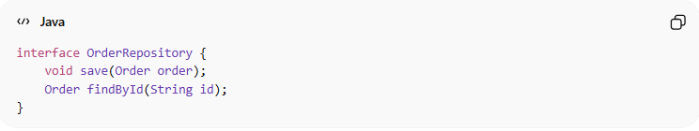
interface OrderRepository {
void save(Order order);
Order findById(String id);
}

6️⃣ Service (Domain Service)
# Source: AI Source: Provided by: [Data Path: Persons Table -> ID Column: 1, Name_En Column: Motasem Essam] -> From: [ChatGPT] on [1/23/2026]
- Contains business logic that doesn’t belong to one entity
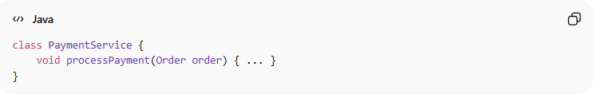
class PaymentService {
void processPayment(Order order) { ... }
}

7️⃣ Ubiquitous Language
# Source: AI Source: Provided by: [Data Path: Persons Table -> ID Column: 1, Name_En Column: Motasem Essam] -> From: [ChatGPT] on [1/23/2026]
- Shared language between developers and business experts
- Example: Order, Invoice, Payment, not DataObject123

❌ Bad Example (Not Using DDD)
# Source: AI Source: Provided by: [Data Path: Persons Table -> ID Column: 1, Name_En Column: Motasem Essam] -> From: [ChatGPT] on [1/23/2026]
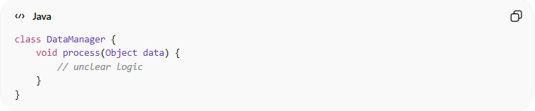
class DataManager {
void process(Object data) {
// unclear logic
}
}
👉 Problems:
- No domain meaning
- Hard to understand business logic

✅ Good Example (DDD Style)
# Source: AI Source: Provided by: [Data Path: Persons Table -> ID Column: 1, Name_En Column: Motasem Essam] -> From: [ChatGPT] on [1/23/2026]
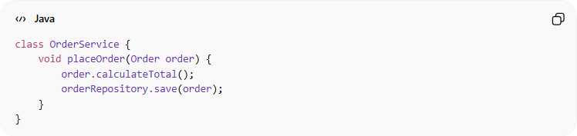
class OrderService {
void placeOrder(Order order) {
order.calculateTotal();
orderRepository.save(order);
}
}
👉 Benefits:
- Clear business meaning
- Matches real-world concepts

⚡ Benefits of DDD
# Source: AI Source: Provided by: [Data Path: Persons Table -> ID Column: 1, Name_En Column: Motasem Essam] -> From: [ChatGPT] on [1/23/2026]
- Aligns code with business needs
- Improves communication with stakeholders
- Handles complex domains effectively
- Makes large systems more maintainable

⚠️ When to Use DDD
# Source: AI Source: Provided by: [Data Path: Persons Table -> ID Column: 1, Name_En Column: Motasem Essam] -> From: [ChatGPT] on [1/23/2026]
- Complex business logic
- Large enterprise systems
- Projects requiring deep domain understanding

🚫 When NOT to Use
# Source: AI Source: Provided by: [Data Path: Persons Table -> ID Column: 1, Name_En Column: Motasem Essam] -> From: [ChatGPT] on [1/23/2026]
- Small/simple applications
- CRUD-only systems (basic create/read/update/delete)

🧾 Summary
# Source: AI Source: Provided by: [Data Path: Persons Table -> ID Column: 1, Name_En Column: Motasem Essam] -> From: [ChatGPT] on [1/23/2026]
DDD helps you:
- Model real-world problems clearly
- Build scalable and maintainable systems
- Bridge the gap between business and code

